**IR items detection system**

**Emitter side:**

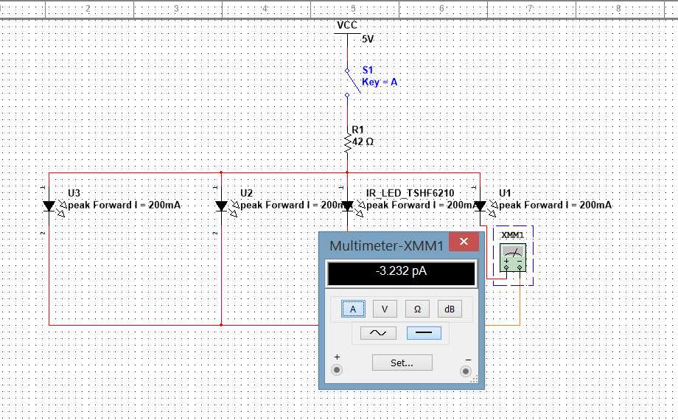

**Working with 42Ω resistor：**

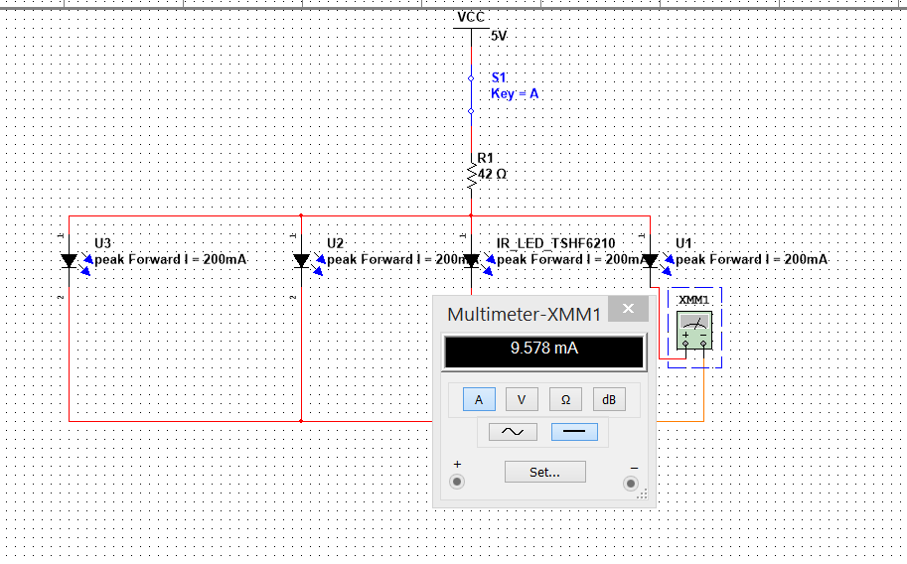

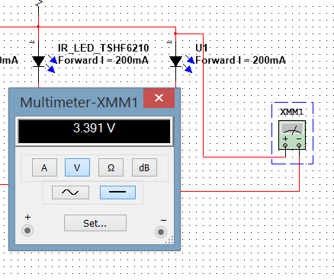

In order to prevent IR led, we use Forward Current as the calculate value for current limited resistor. The power dissipation of led is 160mW, Peak Forward Current (200mA) and the minimum value we set with 10mA. In order to keep PN junction working, the minimum voltage that the Led should be provided is 0.8V. Reserve voltage is 5v, but considering the safety, we use 3.5 volt as the maximum working voltage of Led. Therefore we can figure out that ：

For resistor, 5-0.8=0.01*R1=> R1=420Ω

5-3.5=0.2*R1=> R1=7.5Ω

We will change resistor’s value to adjust the luminance of Led which can match with phototransistor. So, what we have to do is adding a 10Ω prevent resistance and series with a variable resistance.

The IR led picks up TSHF6210 which peak wavelength 890nm. Therefore, in order to match with IR led, the receiver side chooses to use OP803SL

**TSHF6210 IR led:**

In our design, we have to minimize the disturbing between each sensor. So, the angle of intensity should be small. The angle of half intensity of TSHF6210 IR led is only 10 degree which meets our requirement. There is one thing we have noticed that this led which has high speed with rise and fall time which will reduce the reflection time of our this system. Therefore, we decide to use this type of IR led as our IR source.

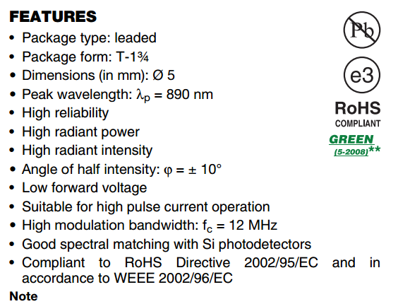

**OP803sl phototransistor:**

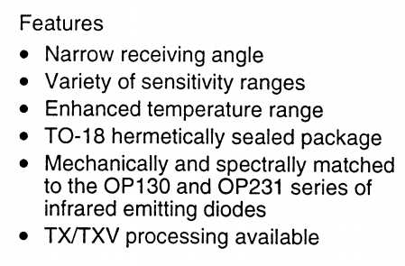

OP803SL is a NPN silicon phototransistor which is with narrow receiving angle. At the beginning, we have considered to use photodarlington OP830SL in our sensor design, but actually the distance between emitter and receive is really close, so that we don’t need higher voltage or current gain. Therefore, we choose the OP803SL as our receiver device. Moreover, OP803SL is more sensitive than most other phototransistor which the Rise and Fall time is lower than 40us when the load resistance is lower than 6000Ω. This feature will increase the accuracy of detection system.

**Receiver side:**

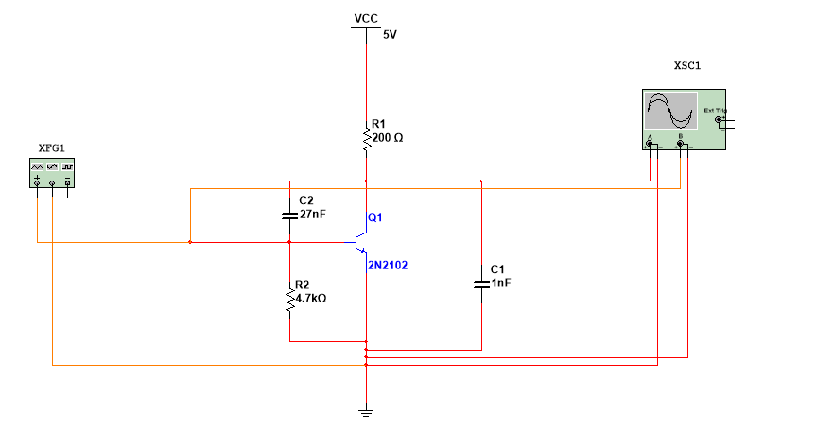 When Vce=5v 4mA< Ic <8mA

When transistor switch is working, we hope to get the shortest reflection time for voltage changing. In order to prevent the time delay happens on switch, which cause of residual charges. We have to add a resistor between base and emitter to discharge. Moreover, the resistor between base and emitter either prevent the disturbing from noise or avoid crossover distortion. For R2, When the collector is dark the Ic current is 1uA. We assume that When BE cut off. Vbe= 0.5v. Thus, R2 should be smaller than 500K. In these cases, it can keep phototransistor working more reliable. Considering the pull-down resistor value cannot be set too big, or it will lead the current in base is too small. So, we choose 4.7k resistor as pull-down resistor. Beside, In order to remove the top of the output signal noise, we add a drop-down capacitance on the output side and an upward capacitance on the base pole to avoid

Before add two capacitances:

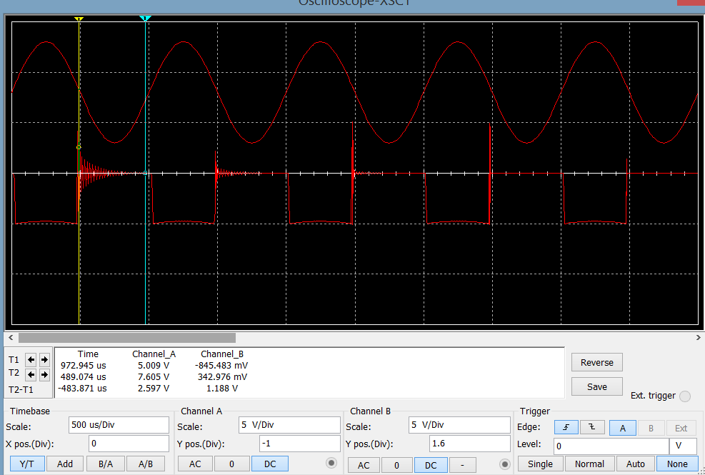

After add two capacitances:

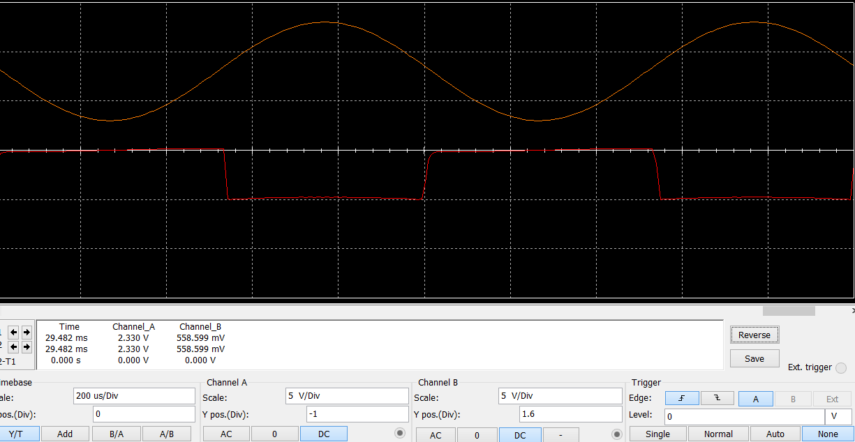

For R1, we consider circuit under sat situation when Vce=1.2v and Ic on-stat = 15mA. The maximum current of I/O is 40mA, continue collector current is 50mA.

R1=(5-1.2-0.7)/15mA=206Ω. So, we choose 200Ω as the value of R1 to save the collector pole, and we choose 1A current source as the power to test this circuit.

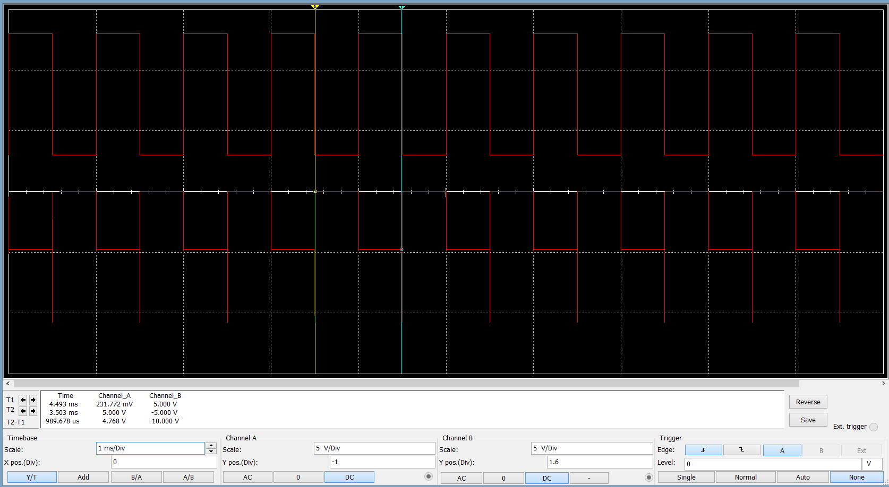

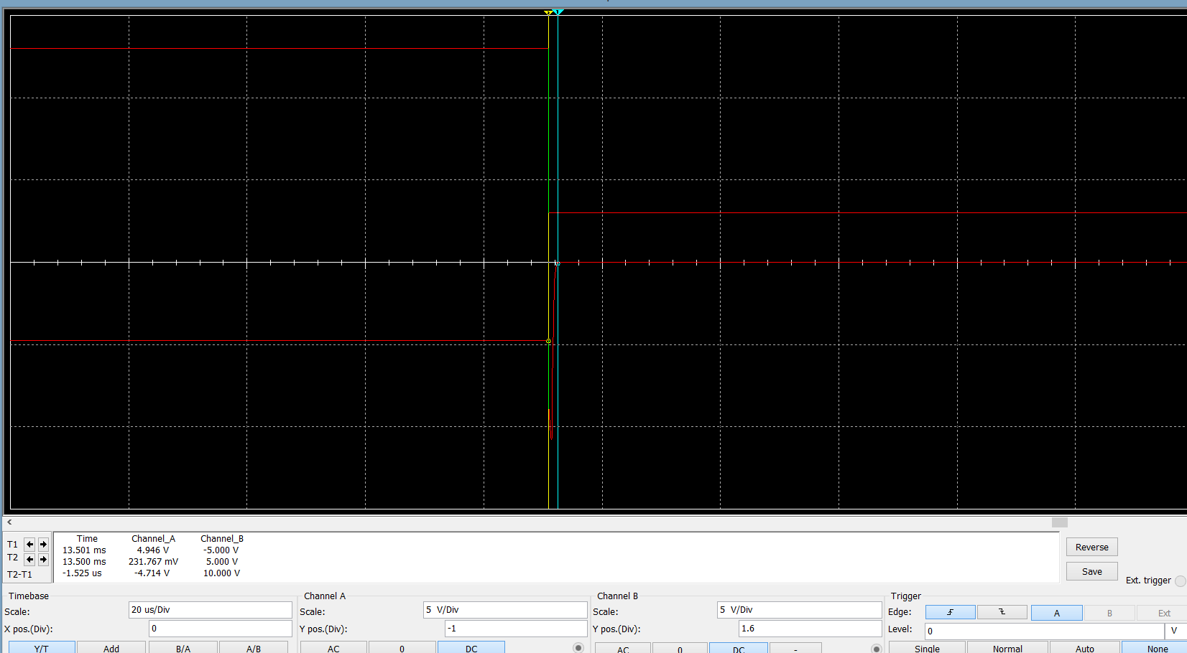

From the result of simulation, the reflection time of state changing is 1.525us which is sensitive enough. S=1/2*a*t2 and V2=2*a*t, => S=1/2*a*(V2/2*a)2=1/2*(V4/4*a)=V4/8*a=> 0.039m=V4/43.2=> V≈6.4mm/s. The minimum thick of item is 4mm, T=4/6.4=0.625s. This time is much bigger than the reflection time of OP803sl. From the output side, we get the relative reasonable square wave which is valid as an input of Arduino board.

Datasheet for **OP803sl** and**TSHF6210** will be provided in the file document.

The components we have to buy:

IR led TSHF 6210

<http://www.alliedelec.com/search/results.aspx?term=TSHF6210&mkwid=sB9UVqMwq&pcrid=18553296726&pkw=tshf6210&pmt=e&gclid=CjwKEAjw8O2hBRDKur2lseLW6C8SJAC-r1J3ggIuxRCjcJ8gc-5lwXTxVQ7V9vMDJ_O7FcmRYDrWThoChaXw_wcB>

OP803sl

<http://www.alliedelec.com/search/productdetail.aspx?SKU=70048590&mkwid=se5W1Qzlq&pcrid=23513685137&pkw=optek%20op803sl&pmt=b&pdv=c&gclid=CjwKEAjw8O2hBRDKur2lseLW6C8SJAC-r1J34Dx94XDoXVvvshI9xvbbjqKIQVQDXGEwxrGQOyN2khoC9pvw_wcB>

25, 102 variable resistances.

<http://www.alliedelec.com/search/productdetail.aspx?SKU=70154383>

If you have better place to buy this type of variable resistance, you can choose that one.

Switch: http://www.alliedelec.com/search/productdetail.aspx?SKU=70192900

For all the capacitors and resistors, I will try to find them in my friend’s lab at first.